**About Jupyter Notebooks:**

<https://jupyter-notebook-beginner-guide.readthedocs.io/en/latest/>

**Installing and Opening Jupyter Notebook Instructions:**

1. Installing Anaconda **(Python 3.7 Version)** to your computer - <https://www.anaconda.com/distribution/>

2. Make sure that during installation you select the option:

**Add Anaconda to my PATH environment variable**

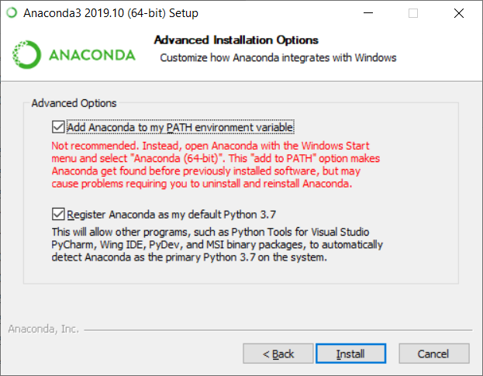

3. After installation is complete open up an Anaconda Prompt

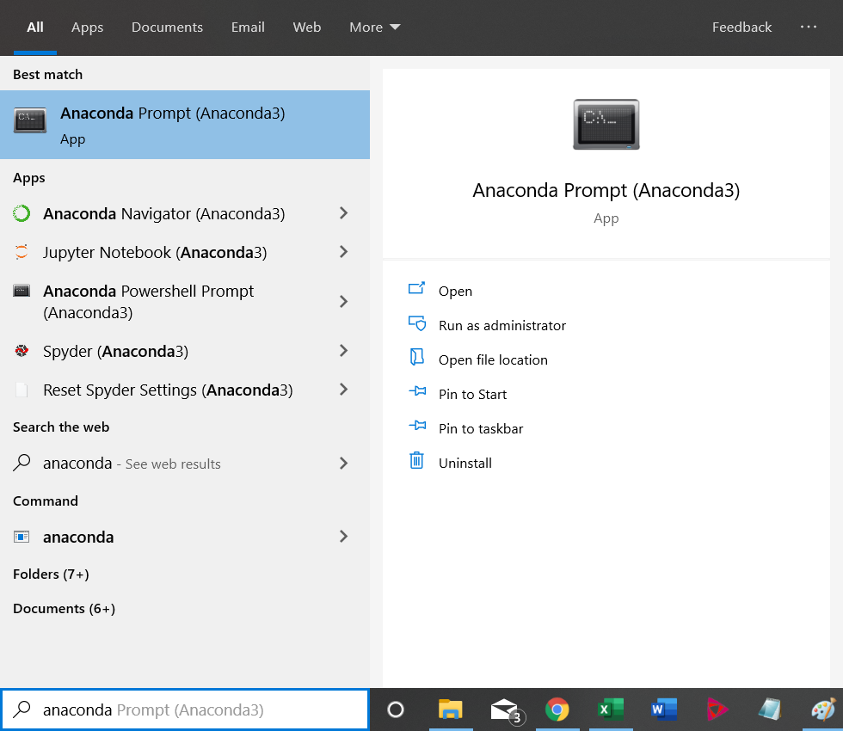

4. In the Anaconda Prompt type the command:

conda install -c conda-forge minimalmodbus

4A. If HTTPS error occurs…

Connect to the internet and re-run the previous command.

4B. When prompted to Proceed ([y]/n)? type

**yes**

Then press the ENTER key on your keyboard

conda install plotly

This will install the necessary modbus master package/library that is required by the attached notebook.

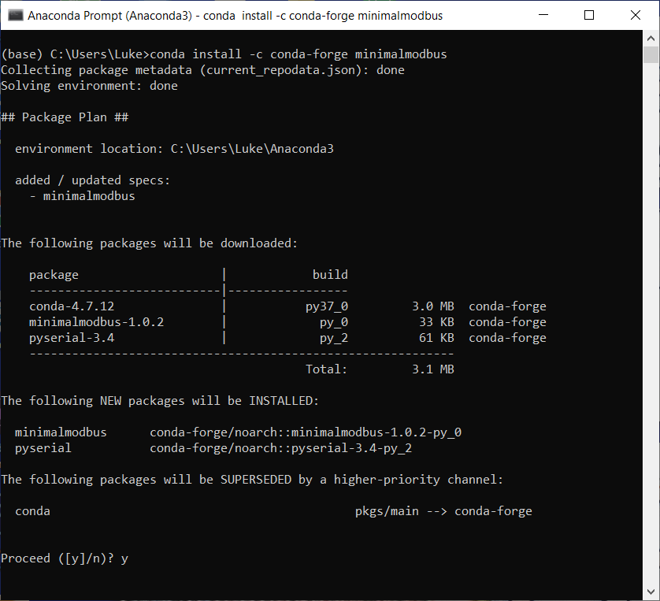

5. Once this completes you will need to open the Anaconda Navigator

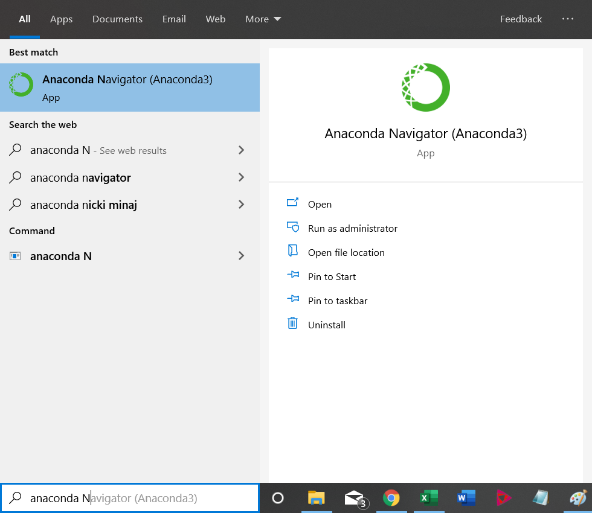

6. Once the Navagator opens you will Launch Jupyter Notebooks

​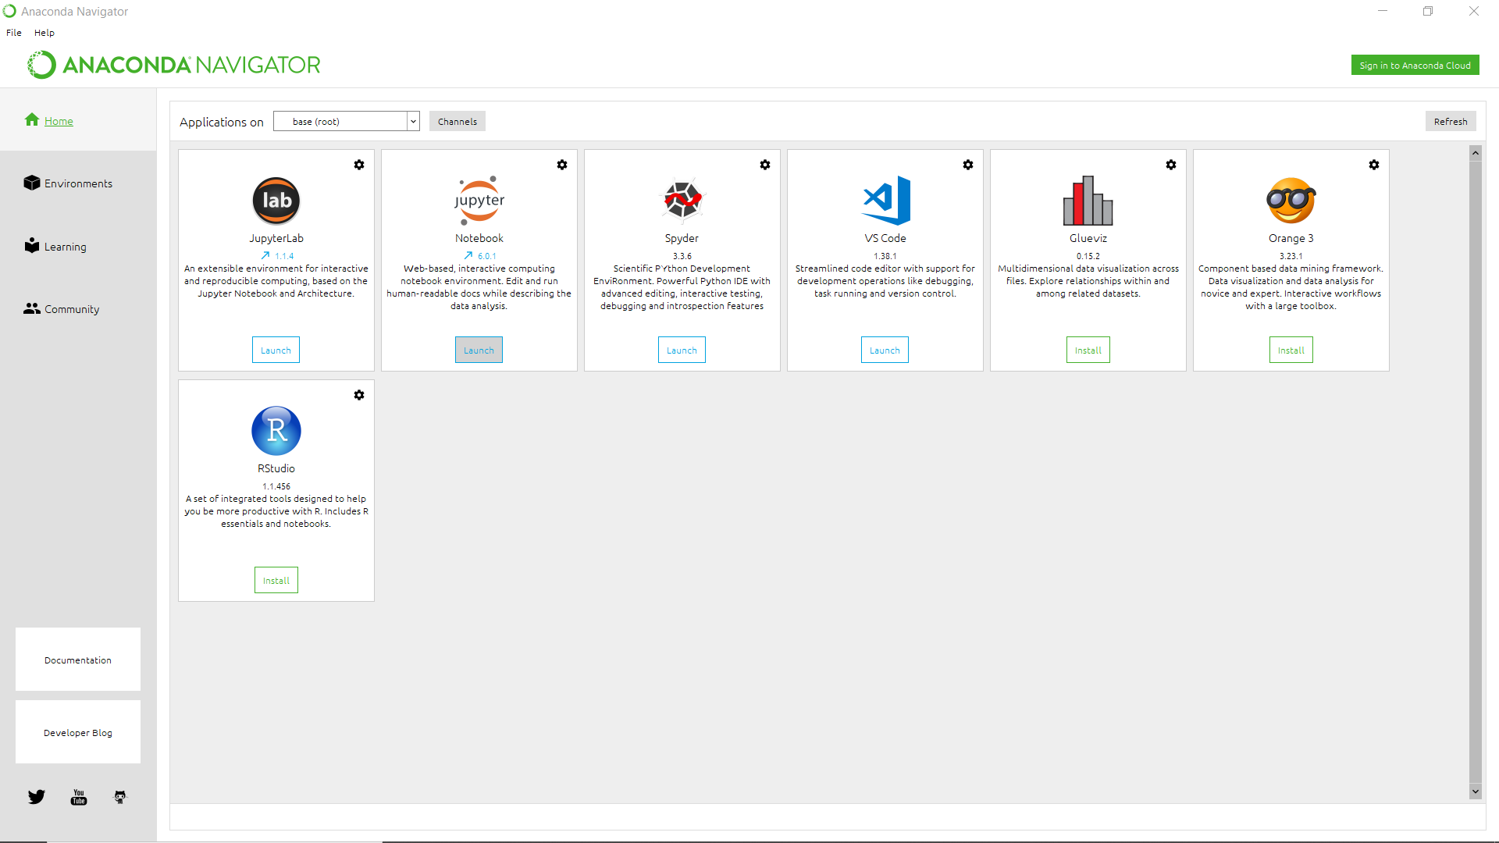

8. After you have Launched Jupyter, a web browser should open.

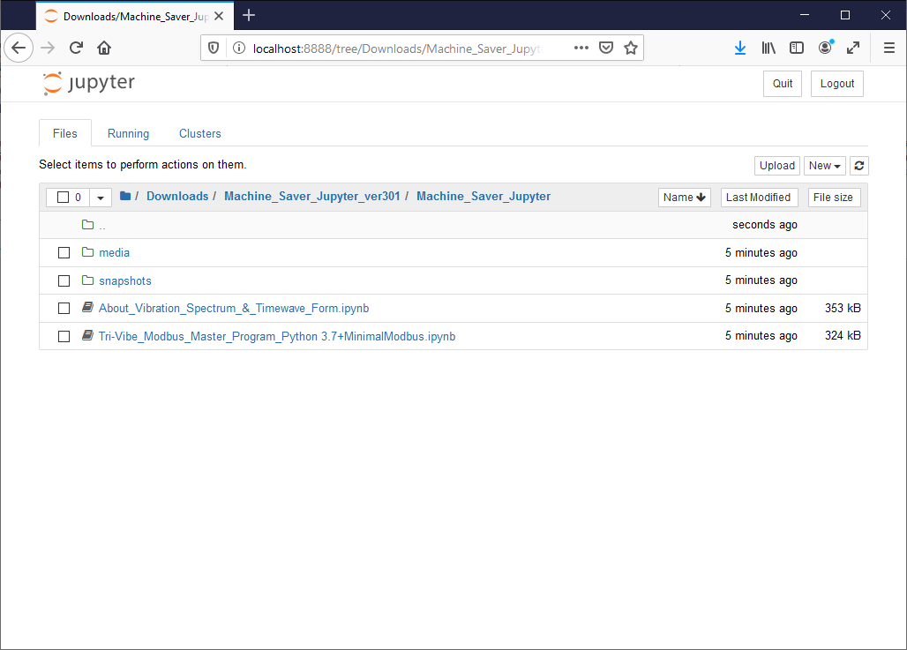

9. Navigate to the directory/folder where you extracted and saved the notebook file (often in Downloads) and click on the notebook file:

**Tri-Vibe_Modbus_Master_Program_Python 3.7+MinimalModbus.ipynb**

**Sensor Connection and Notebook Execution Instructions:**

10. Read the notebook and follow the instructions to power the sensor, wire sensor to USB-RS485 converter and connect to your computer.

11. Run the notebook to find the port of your USB-RS485 converter.

**Note to Run the notebook click the following button:**

​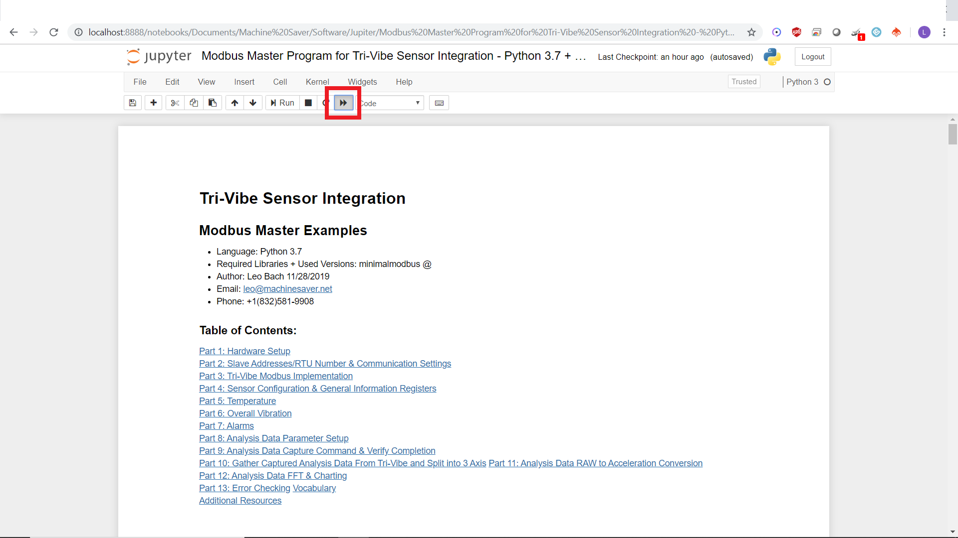

**Then Select the prompt in RED:**

​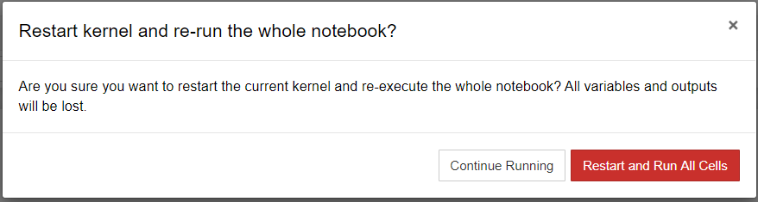

**The notebook should be run anytime you change any part of the code!**

12. Enter the return value of the found port into Part 2 along with your Tri-Vibe Sensor's Slave ID (last 2 digits of the serial number)

13. Re-Run the notebook to see the relevant data from each code block listed below its section.